M S AYURVED MEDICAL COLLEGE,KUDWA,GONDIA
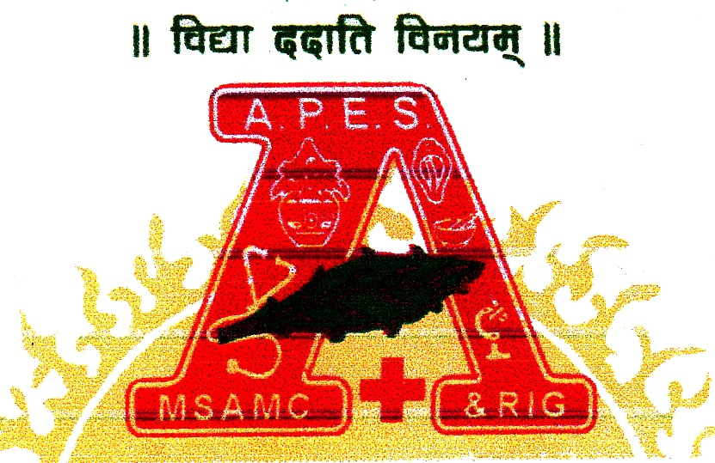
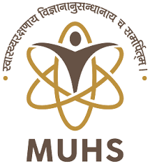

Guest lectures/Webinar
Name of Organizing Department: Department of Samhita Siddhant, MSAMC, Kudwa, Gondia
Date: 05/08/2019 Time: 11.00 AM to 2.00 PM
Guest:- Prof. Dr. Suresh Katre, HOD, Dept. of Kayachikitsa.
Moderator of the session:- Dr. Deepak Rahangdale, Lecturer, Dept of samhita siddhant.
Topic/ Theme:- CHARAK JAYANTI
Proceedings:
Charak jayanti Utsav was celebrated at Dept of Samhita Siddhant, MSAMC, Kudwa, Gondia on the occasion of Nagpanchami, Shuklapanchmi of 5th of August 2019.
Inauguration and Lamp lighting was done by Prof. Dr Suresh Katre HOD, Dept of Kayachikitsa and Mrs. Minakshi Katre along with Principal Dr. Jaimala Shirke.
Dhanvantary sthavan chanted by students of first year BAMS.
Further, Dr. Vaishali Nakhale HOD Dept. of samhita Siddhant enlightened the importance of charak jayanti celebration and importance of samhita in present era. During the event of celebration Samhita Pathan, Debate compitation, Shloka recitation was conducted.
Moderator for the session and vote of thanks was given by Dr Deepak Rahangdale, Lecturer,Dept of samhita siddhant.
For this event all the students of first, second, Third year BAMS, Interns and faculties of other departments had taken benefit of session.

